Name: _____________________

Geology 51-102
Instructor Eric Hiatt

Digital Artifact Assignment: Geology of Wisconsin

In Wisconsin the rocks at or under the surface sediments (mostly glacial sediments) range from about 2 billion years old to about 350 million years old. The bedrock geology map of Wisconsin shows the rocks that make up Wisconsin and gives the rock type and age (as geologic period or era names) in the explanation.

When you have completed this assignment, upload it to your ePortfolio through D2L. If you have problems, contact: John Robertson, ePortfolio specialist.

Click on the map below to download a higher-resolution version:

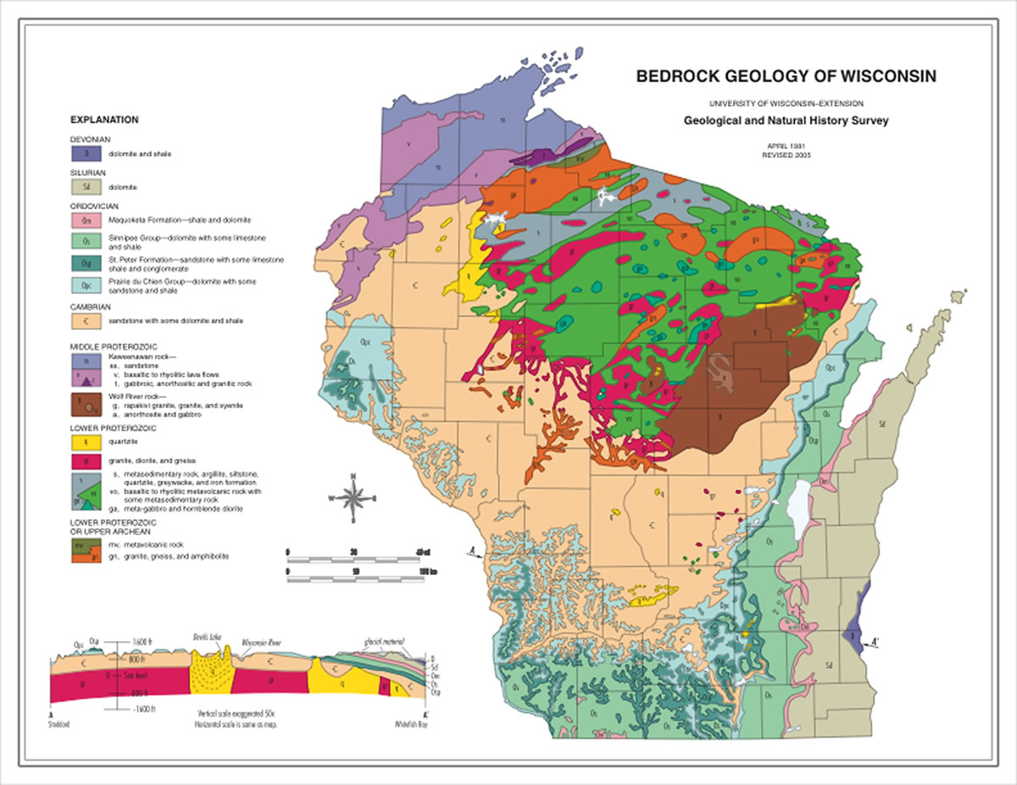

Figure 1. Bedrock geology map for Wisconsin from the Wisconsin Geological Survey. You can access and download a larger, more detailed version of the bedrock geology map here at the Wisconsin Geological Survey web site. And you can obtain other digital publications here.

- Using the Bedrock Geology map above (and link to the higher-resolution version), what is the age (name of geologic period or approximate age of rocks that make up the Door Peninsula (NE point of Wisconsin east of Green Bay)? What rock type (name) is this?
- The sedimentary rock layers in eastern Wisconsin once extended across the entire state. Why are the youngest rock layers now only found in the very eastern edge of Wisconsin? What rock type are these?

- What is the age (geologic period or era name) of rocks in the area where you grew up? If you are not from Wisconsin, what is the age of the rocks under Oshkosh?

- Rock layers that occur near the surface of eastern Wisconsin are found at more than 1000 meters (3,000 feet) depth in central Michigan. Why does this occur? (See Figure 2.)

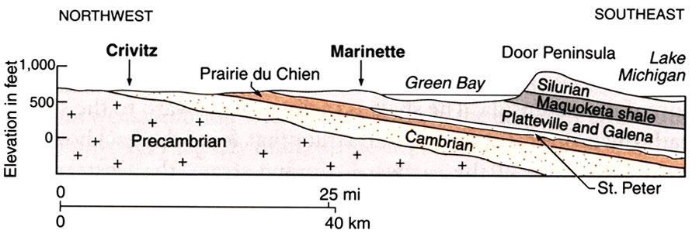

Figure 2. Diagram showing a cross sectional view of the bedrock geology across Green Bay. From Dott and Attig, 2004, Roadside Geology of Wisconsin: Mountain Press.

Part II. Photos of geologic features in Wisconsin.

Add photos (at least one) below that capture some aspect of Wisconsin geology and add a caption with details regarding the location. You can also upload videos and refer to them in this document. Then refer to the geologic map of Wisconsin to determine the approximate age and rock type in your photo.

Example:
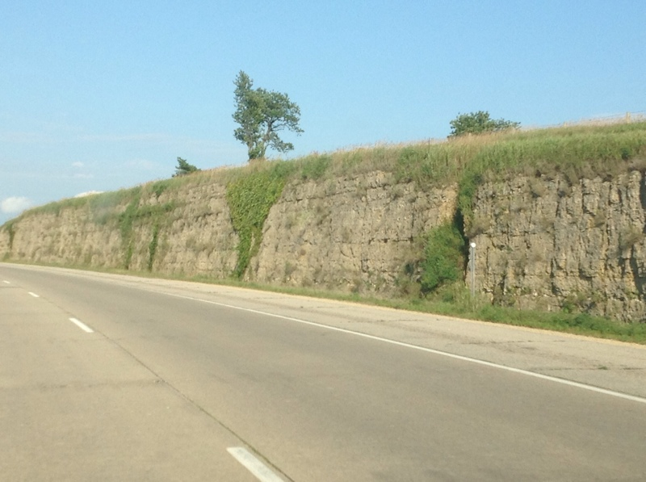

Outcrop along Highway 151 near Mineral Point that shows dolostone and sandstone of the Ordovician Prairie du Chien Group.

Add photos below:
Add photos (at least one) below that capture some aspect of Wisconsin geology and add a caption with details regarding the location. You can also upload videos and refer to them in this document. Then refer to the geologic map of Wisconsin to determine the approximate age and rock type in your photo.

When you have completed this assignment, upload it to your ePortfolio through D2L. If you have problems, contact: John Robertson, ePortfolio specialist.

